Label iQ - Quick Reference Guide for Judges
Login Credentials
Role | Password | Access Level
Patient | patient | 8 of 9 database views
Physician | physician | All 9 database views
Judge | judge | All 9 views + SQL query visibility
Username: Any value (e.g., "judge1")
Note: Passwords are case-sensitive (use lowercase)
Recommended Test Flow
1. Login as Judge
- Username: judge1
- Password: judge
- Role: Select "Judge"
2. Try These Sample Questions
Basic Drug Info:
"What is ENTRESTO used for?"
Dosing Question:
"What is the recommended dose for JARDIANCE?"
Safety Question:
"What are the side effects of HUMIRA?"
Interaction Question:
"Does ELIQUIS interact with aspirin?"
3. Features to Notice
- Drug Logo Grid: Click any logo to auto-populate a question
- SQL Query Panel: Judges can view the generated SQL (click to reveal)
- Response Metadata: Shows model name, response time, tables used
- Query History Sidebar: Only visible to Judge role
Architecture Diagram
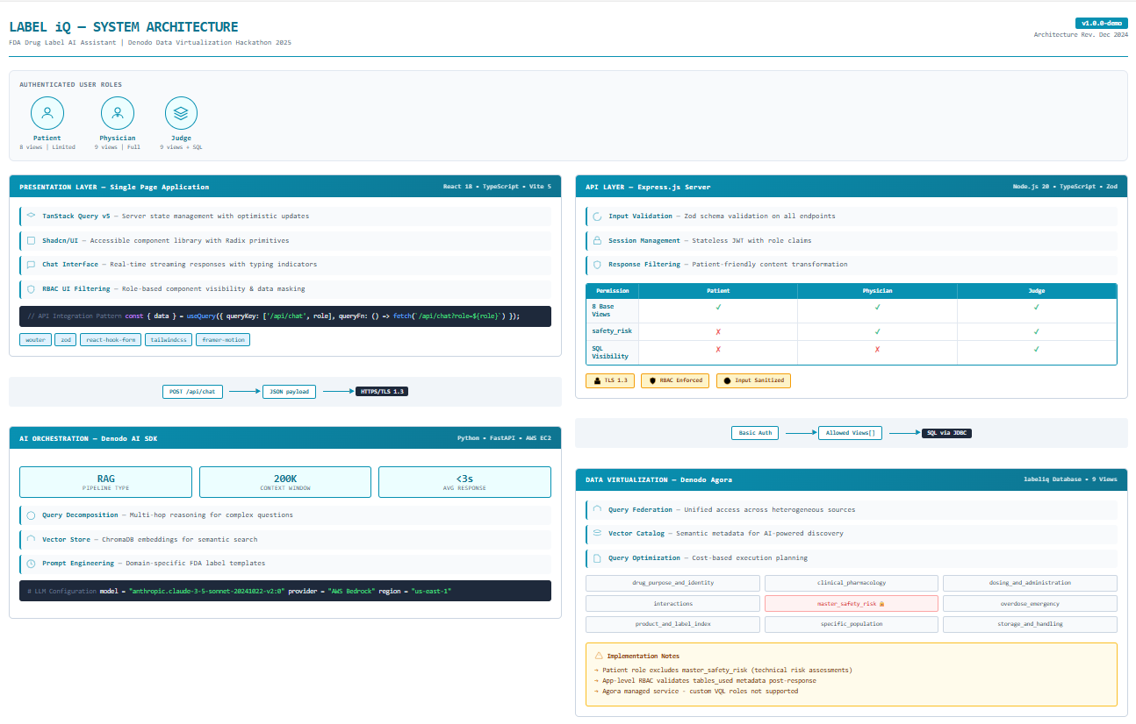
Key Technical Highlights
Component | Technology
Frontend | React 18 + TypeScript
Backend | Express.js + Node.js 20
AI | Denodo AI SDK + Claude 3.5 Sonnet
Data | Denodo Agora (9 virtualized views)
LLM | AWS Bedrock (us-east-1)

RBAC Demo
Try logging in as different roles to see access control in action:
- As Patient: Notice master_safety_risk view is excluded
- As Physician: Full access but SQL queries hidden
- As Judge: Full access + SQL query visibility

Available Drug Labels (14 Total)
Biktarvy, ELIQUIS, ENBREL, ENTRESTO, FARXIGA, HUMIRA, IBRANCE, Imbruvica, JAKAFI, JANUVIA, JARDIANCE, Lantus, Linzess

Massive Insights - Denodo Hackathon 2025

